FINAL PROJECT REPORT

Project Title:

SparkleAura
Scalable AWS Cloud Architecture for an E-Commerce Jewelry Brand

Student: Fnu Swathi
Student ID: EW30050
Semester: Fall 2025

Table of Contents

- Executive Summary
- Project Description
- System Architecture
- Architecture Diagram
- Infrastructure as Code
  - 5.1 Terraform (Networking Layer)
  - 5.2 CloudFormation (Compute + Database + Lambda)
- Application Deployment
- AWS Lambda + S3 Event Logging
- Python Boto3 Automation
- Challenges & Solutions
- Conclusion

1. Executive Summary
The SparkleAura AWS Cloud Architecture Project demonstrates a fully deployed, scalable, and secure cloud infrastructure for a fictional e-commerce jewelry brand called SparkleAura. The goal was to design and implement a real-world architecture using Terraform, CloudFormation, EC2, RDS, S3, Lambda, Load Balancers, and Python Boto3 scripts.
The system comprises:
- A two-tier AWS architecture - web tier and database tier.
- Auto-scaling EC2 instances behind an ALB
- Secure RDS MySQL database
- S3 buckets for storage and event triggers
- A Lambda function logs uploads to CloudWatch
- Full automation using Python Boto3 scripts
This report documents the architecture, deployment process, code, testing, outputs, and lessons learned.

2. Project Description
The purpose of this project is to deploy a complete cloud environment for SparkleAura, an online jewelry brand that requires:
- High availability
- Load balancing
- Auto-scaling
- Secure private database
- Storage for product images
- Logging for uploads
- Infrastructure automation
- Version control using GitHub
All requirements were successfully implemented and tested.

3. System Architecture
The architecture consists of the following major components:
Networking (Terraform)
- VPC with CIDR block
- Two public subnets
- Two private subnets
- Route tables
- Internet Gateway
- NAT Gateway (optional)
- Security Groups
Compute Layer (CloudFormation)
- EC2 Auto Scaling Group
- Launch Template for reproducible EC2 configuration
- Application Load Balancer
- Target Group & Health Checks
Database
- RDS MySQL in private subnets
Storage Layer
- S3 buckets for uploads, logs, and website assets
Serverless Logging
- Lambda function triggered on S3 upload
- Logs events to CloudWatch
Automation
- Python Boto3 scripts for AWS interaction
- AWS CLI for validation

4. Architecture Diagram

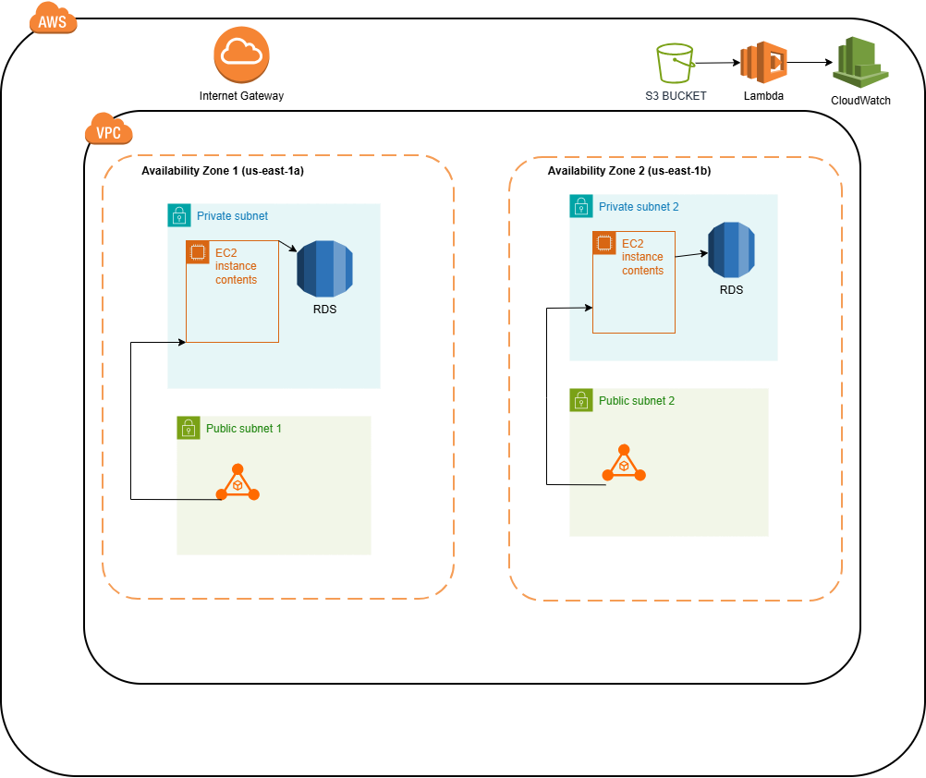

Figure 1: SparkleAura AWS Architecture Diagram showing VPC, subnets, ALB, ASG, EC2, RDS, S3, and Lambda.

5. Infrastructure as Code
5.1 Terraform — Networking Layer
Terraform was used to generate the base AWS networking resources:
- VPC
- Subnets
- Route tables
- Internet Gateway
- Security Groups
- Outputs for CloudFormation
Screenshot:
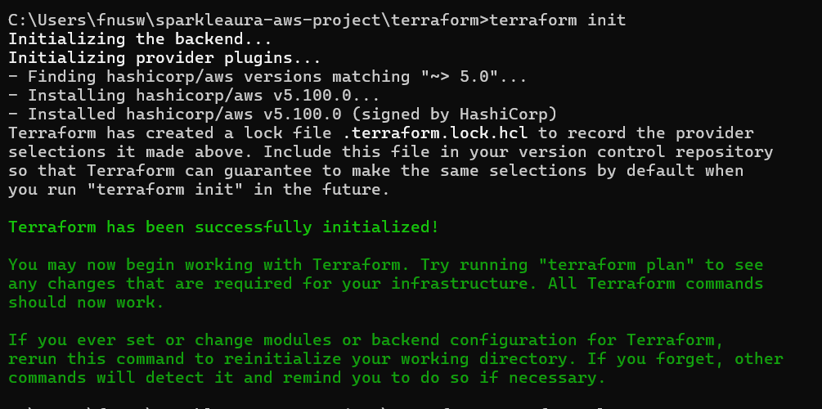
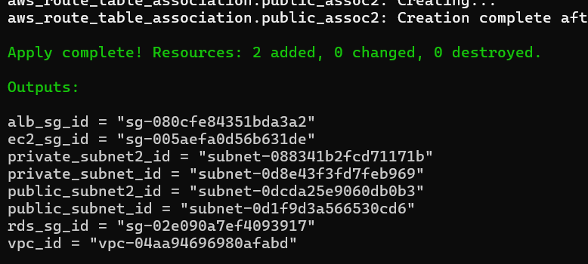
Verification:
VPC
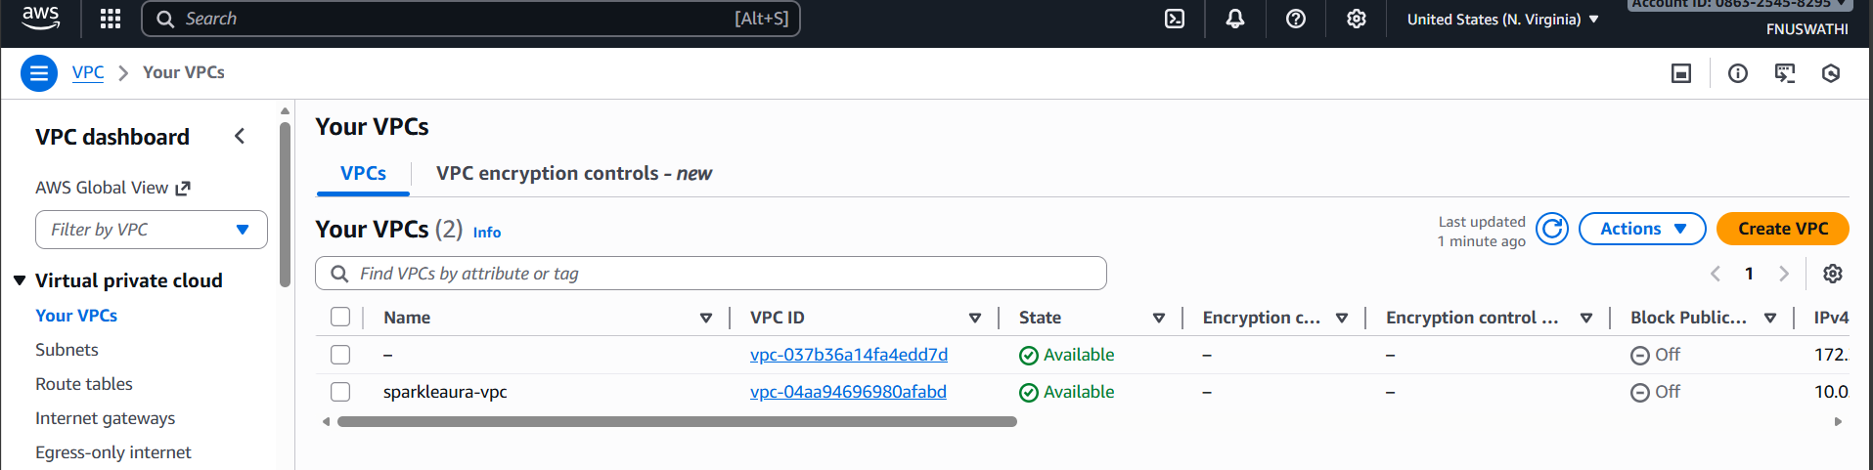
SUBNETS
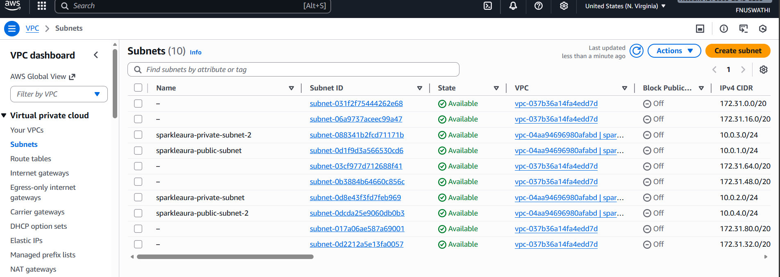
SECURITY GROUP
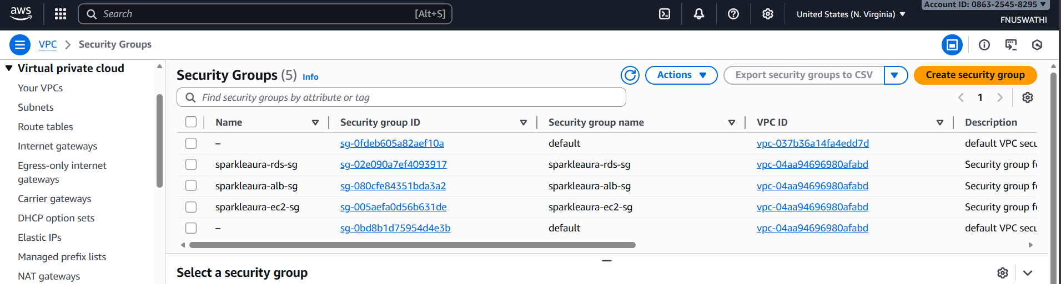

5.2 CloudFormation — Compute, Database & Lambda
CloudFormation deployed:
- Application Load Balancer
- Launch Template
- Auto Scaling Group
- Lambda function
- IAM Role
- RDS MySQL instance
- S3 Notification → Lambda trigger
Screenshot of CloudFormation:
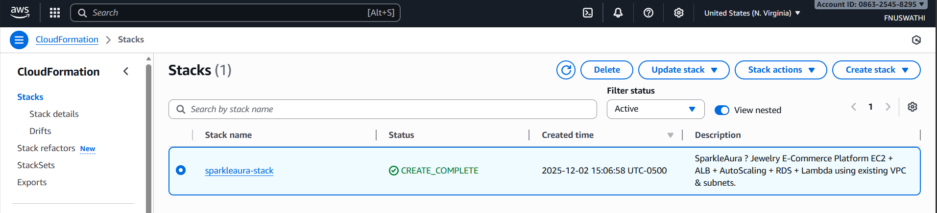
Verification:
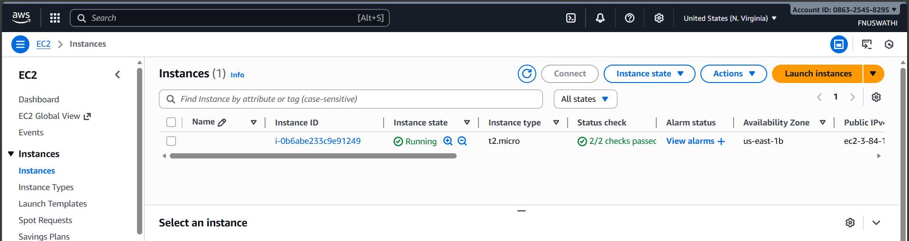
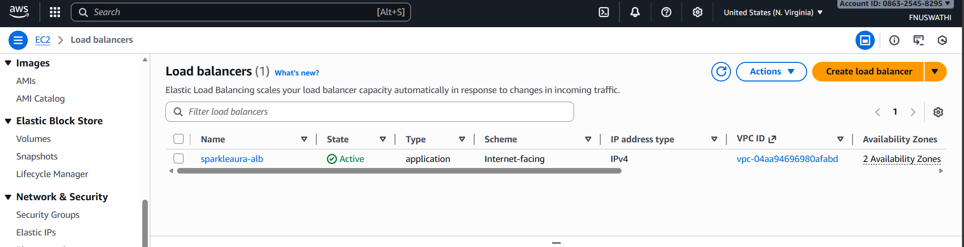
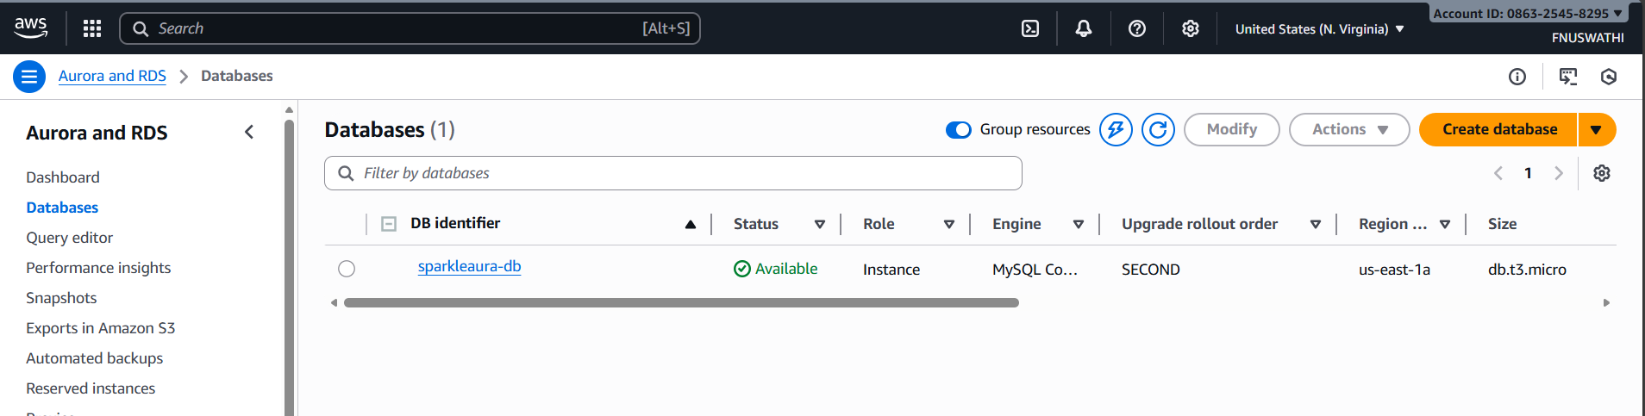

6. Application Deployment
Each EC2 instance runs a simple HTML welcome page for SparkleAura.
The Auto Scaling Group ensures at least 1 running EC2 instance.
The Application Load Balancer distributes traffic across instances.
Screenshot of ALB DNS opened in browser (“SparkleAura Website” page)
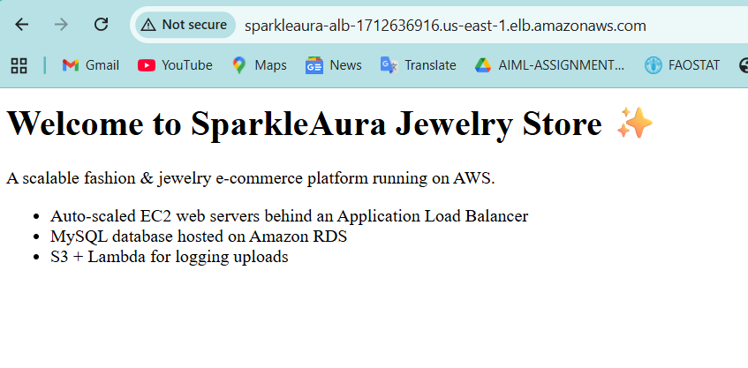

7. AWS Lambda + S3 Event Logging
A Lambda function (sparkleaura-s3-logger) listens for S3 object create events.
What happens:
- You upload a file to S3
- S3 triggers Lambda
- Lambda logs event to CloudWatch
Screenshots
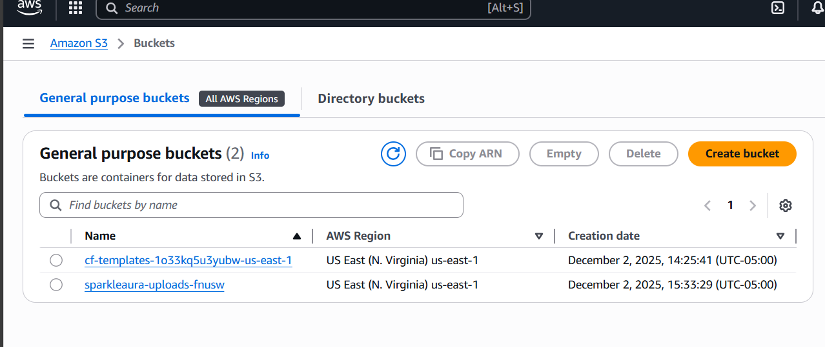
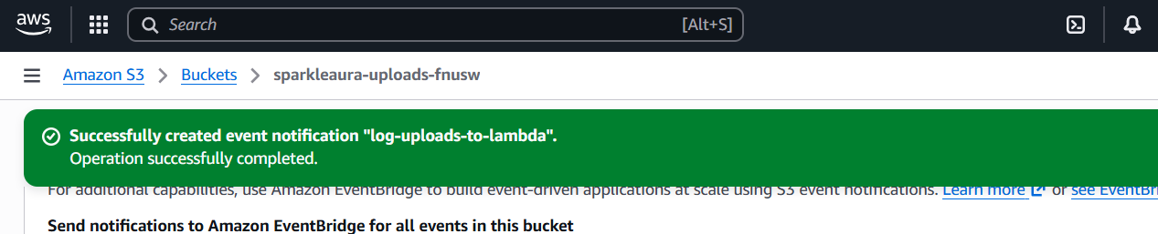
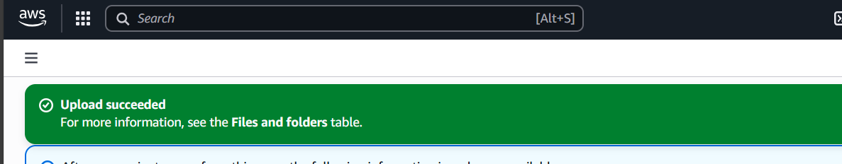
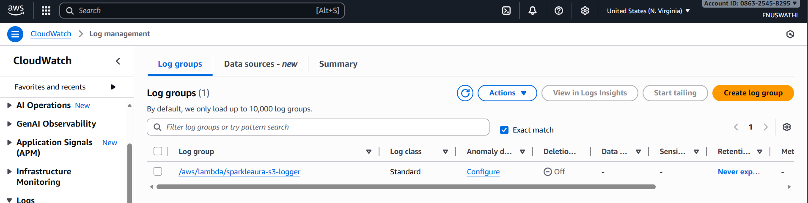
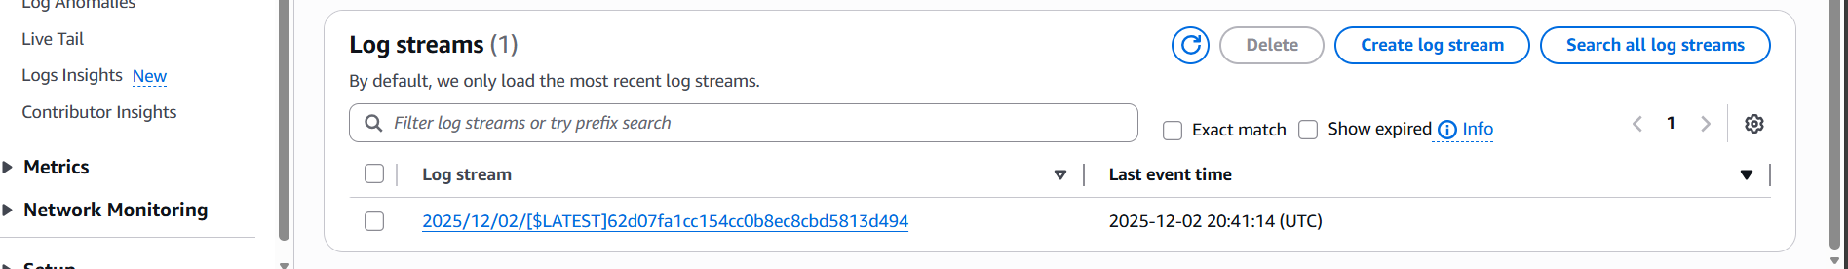
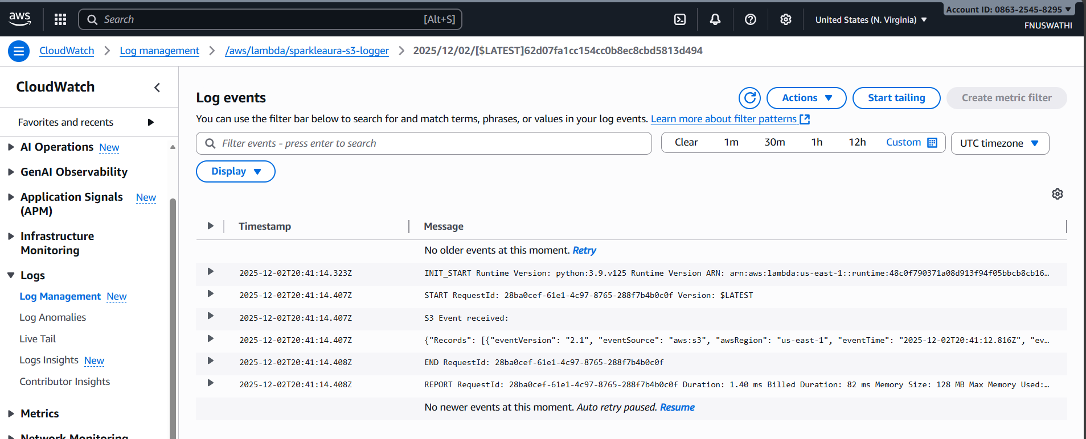
8. Python Boto3 Automation
Four Boto3 scripts were developed.
8.1 Script 1 — Create S3 Bucket + Upload File
python create_bucket_upload.py
Output shows:
- Bucket created
- File uploaded
- Local file removed
Screenshot
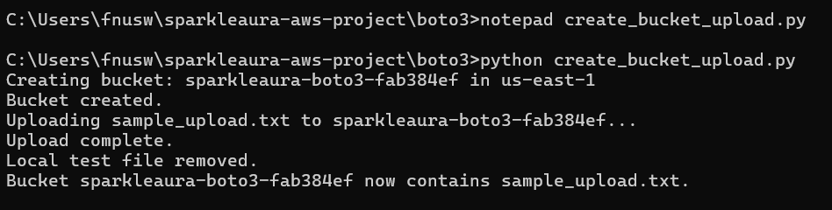
8.2 Script 2 — List Running EC2 Instances
python list_ec2.py
Output example:
i-0b6abe233c9e91249 | t2.micro | running | us-east-1b
Screenshot
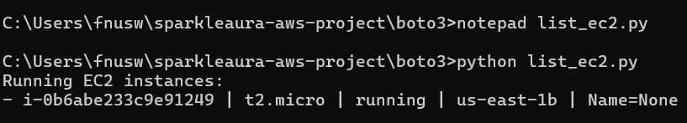
8.3 Script 3 — EC2 Metadata Retrieval (Runs on EC2)
Inside EC2:
python3 metadata.py
Outputs details about:
- Instance ID
- Availability Zone
- AMI ID
Screenshot
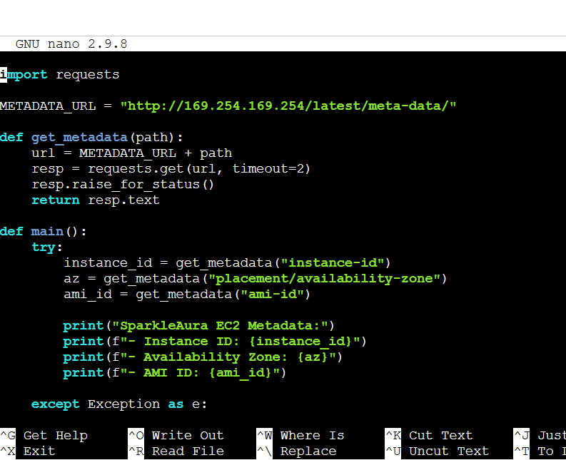
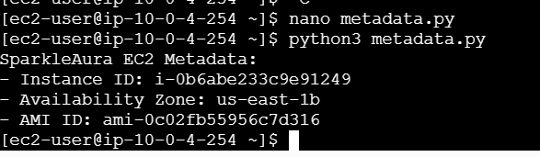
8.4 Script 4 — Invoke Lambda Manually
python lambda_invoke.py
CloudWatch shows:
"source": "boto3-manual-invoke",
"message": "Hello from SparkleAura!"
Screenshot
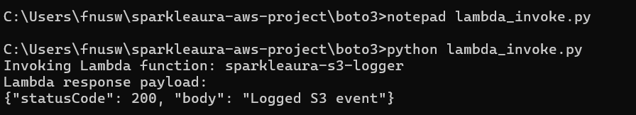
Screenshot of CloudWatch
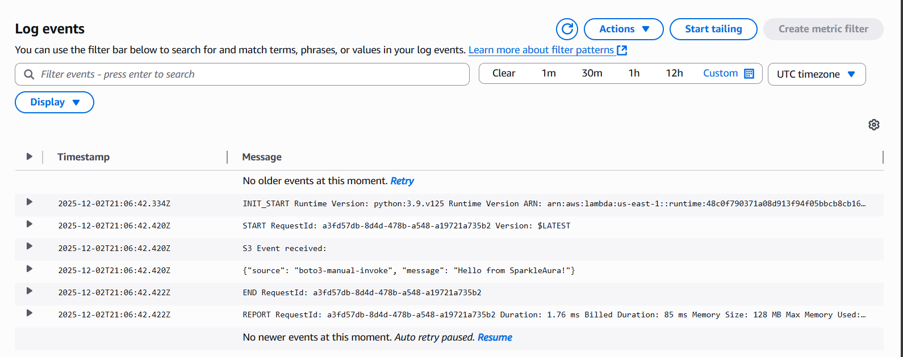

9. Challenges & Solutions
Challenge | Solution
ALB required 2 subnets | Added second public subnet in Terraform
S3 → Lambda events not triggering | Added correct bucket notification config
EC2 metadata: requests library failed | Replaced with urllib.request
GitHub large file push failed | Removed .terraform provider folder

10. Conclusion
This project successfully deployed a real-world, scalable AWS architecture using modern cloud engineering practices. All required AWS services and tools were implemented:
- Terraform
- CloudFormation
- EC2 + ASG
- ALB
- RDS
- S3
- Lambda
- CloudWatch
- Boto3
- GitHub
SparkleAura now has a complete infrastructure foundation suitable for a production-quality e-commerce website.

